**AES Class Activity**

Class Activity 2 : The app allow you to choose files from their computers and encrypt them client-side with a pass phrase.

1. Using HTML Editors: Notepad ++, Sublime Text, Visual Studio Code. Open the source code in the asset folder
2. The “Script” in the JS folder is using AES JavaScript library
3. Open the index.html from the files and analyze how the library is called
4. Open the Script and change the file extension for encrypted file, password, maximum size of file your application can encrypt.

Before

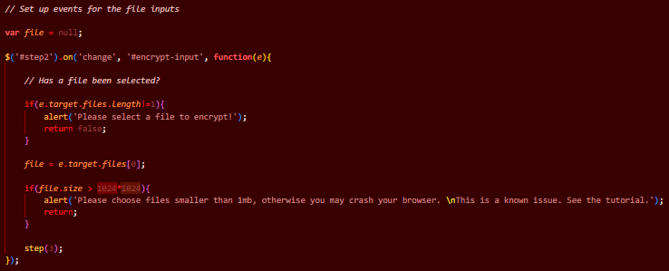

After

Before

After

Before

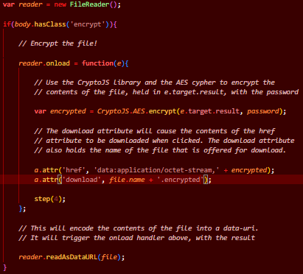

After

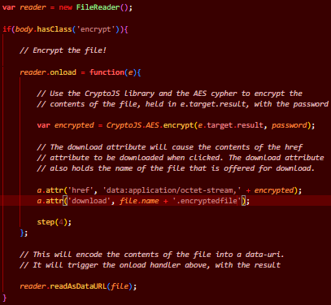

1. Modify the index file and host the app in your preferred web server.

What I modified in the index file was to make the links secure by changing them from http to https. The live site is on [click here](https://javascriptaesassignment.netlify.app/) or [click here](https://olivernjeru.github.io/components/javascript-file-encrypter/index.html) or [click here](https://javascriptaesassignment.000webhostapp.com/).